TECHNICAL PROPOSAL
BRAC JPGSPH Website Redevelopment,
Admin Panel and Security-First Rebuild

1. Executive Summary
This proposal presents a full redevelopment approach for the BRAC James P Grant School of Public Health website, covering discovery, UI/UX redesign, frontend and backend development, content administration capability, controlled migration, testing, deployment, and post-launch stabilization. The solution is intentionally scoped to the requirements provided, avoiding non-essential features that would increase cost or complexity.
The proposed solution will deliver a modern, accessible, responsive, and easy-to-manage institutional website that clearly represents BRAC JPGSPH’s education, research, training, impact, and engagement activities. In parallel, the implementation approach incorporates the security-rebuild priorities from the recovery plan, including clean-environment deployment, access hardening, environment separation, dependency validation, and production-readiness testing.
The website will be developed from scratch with a new UI/UX layer and a complete admin panel so that non-technical teams can manage page sections, notices, events, media, documents, staff profiles, and key website features without code-level dependency.

2. Project Understanding
Based on the requirement document, the target platform is a public-facing institutional website supported by a role-based admin panel. The website must serve a wide stakeholder base including prospective students, current students, researchers, donors, partners, staff, alumni, and institutional leadership. It must highlight the school’s academic programmes, research centres, publications, projects, training offerings, impact stories, events, careers, and related external platforms while remaining easy to navigate and easy to maintain.
Based on the security analysis and recovery plan, the current digital environment has also experienced a serious cyber incident and therefore the new solution should not be treated as a standard website refresh alone. It should be executed as a controlled rebuild with secure infrastructure setup, codebase trust restoration, access control hardening, testing, and live stabilization embedded into the delivery lifecycle.

3. Proposed Solution Scope
Layer | Included Scope | Key Notes
Discovery & UX | Information architecture, wireframe direction, UI design system, responsive page templates | New UI/UX design is included
Public Website | Homepage, About, Education, Research, Impact, Training, Engage With Us, External Platforms, News & Events, Contact | Built from scratch and optimized for responsive web delivery
Admin Panel | Page-wise content management, section control, notices/events, media/documents, staff profile flow, user roles | Complete admin panel included
Security Rebuild | Clean deployment environment, hardening baseline, credential reset support, staging/production separation, dependency validation | Aligned to recovery-plan priorities
Quality & Launch | Functional testing, regression testing, vulnerability checks, deployment, QA support, go-live stabilization | Commercial section excluded as requested

4. Functional Modules in Scope

4.1 Public Website Modules
- Homepage with editable banner/slider, quick links, about summary, featured programmes, notices, events, achievements/highlights, optional testimonials, videos, and footer content.
- About section covering institutional overview, management committee, research strategy team, staff directory, funders and partners, newsletters, and annual reports.
- Education section covering programme listings and detail pages, curriculum or key programme information, faculty directory, and alumni/testimonial content where required.
- Research section covering overview, centres of excellence, hubs, projects, publications, IRB information, COVID-19 content, and data repository content pages.
- Impact section covering impact overview, resources, media, events where relevant, and Bangladesh Health Watch-related visibility.
- Training section covering course/training listings, detail pages, and upcoming training schedules.
- Engage With Us section covering careers, partnerships, alumni, and exchange programme content.
- External Platforms section for controlled links to Bangladesh Health Watch, EV4GH, and other project websites.
- News & Events listing and detail pages.
- Contact page with contact details, map/location, inquiry form, and newsletter/updates subscription section.

4.2 Admin Panel Modules
- Dashboard with content and publishing overview.
- Page management with editable content blocks, section show/hide, reorder, and preview-before-publish workflow.
- Feature controls for navigation visibility, homepage section visibility, and prioritization of highlighted content.
- Programme management for education and training entries.
- Research management for centres, hubs, projects, publications, reports, datasets, and related links.
- News, notices, events, and career opportunity management.
- Media and document library management.
- Staff and faculty profile management including designated approval flow where required.
- User and role management for Super Admin, Editor, and Staff-level access.

4.3 Controlled Advanced Capability
The requirement document mentions AI-integrated search. To control delivery cost and project risk, the proposal recommends a phased implementation-ready architecture: the first release should establish a high-quality structured search foundation with indexing, tagging, filtering, and content-type search, while keeping the architecture ready for future semantic enhancement.

5. Proposed Technical Approach
- Discovery and planning: confirm sitemap, content model, user journeys, page inventory, approval flow, and migration approach.
- UX and UI design: create responsive design system, page templates, reusable components, and approved interface direction aligned with BRAC JPGSPH branding.
- Solution architecture and setup: establish development, staging, and production environments with secure baseline configuration.
- Backend and admin development: implement content structures, workflows, role-based permissions, media/document handling, and admin controls.
- Frontend development: build responsive pages and dynamic content rendering based on CMS-managed structures.
- Data/content migration support: map existing content, documents, staff profiles, and publication-related assets into the new structure as applicable.
- Testing and hardening: run multi-level QA, regression, access control checks, performance validation, and vulnerability-focused review.
- Deployment and stabilization: execute controlled go-live with production checks, indexing readiness, analytics setup, monitoring, and post-launch stabilization.

7. Proposed Technical Stack
Layer | Recommended Stack | Rationale
Frontend | Next.js / React | Modern, high-performance responsive frontend with strong SEO support and reusable component architecture.
Backend / CMS | Laravel | Well-suited for secure admin panels, content workflows, role-based access, and maintainable custom website backends.
Database | MySQL or PostgreSQL | Reliable relational storage for structured website content, users, roles, metadata, and logs.
Admin UI | Laravel Blade or React-based admin interface | Supports a practical and maintainable admin experience without unnecessary overhead.
Search Foundation | Structured full-site search with metadata indexing | Delivers controlled search capability first, while preserving future AI-search extensibility.
File Storage | Secure object/file storage with backup policy | Supports documents, reports, images, and publication assets.
Hosting | Cloud VM or managed Linux server with separate staging and production | Supports secure rebuild, role separation, backup, and controlled deployment.
Security Controls | WAF, SSL, MFA/2FA for admin, audit logs, backup and restore routines | Directly aligned with the security recovery objectives.

6. Development Methodology
A structured Agile delivery model is recommended for this project, using short sprints with milestone-based reviews. This approach is appropriate because the website contains a broad range of institutional content types and administrative workflows, while also requiring close review of design, content structure, security, and approval logic.
Sprint | Focus | Primary Output | Review Point
1 | Discovery | Sitemap, content model, feature confirmation, wireframe direction | Requirement and structure approval
2 | Design | UI kit, key page designs, responsive patterns | Design approval
3-4 | Build | CMS/admin, public frontend, integrations, role controls | Sprint demos
5 | QA | Fixes, validation, training prep, deployment checklist | QA sign-off
6 | Go-Live | Production release and stabilization | Launch readiness review

8. Security and Recovery-Oriented Build Strategy
Because the supplied security analysis identifies compromise through shell-level access, malware injection, persistence mechanisms, and residual risk, the redevelopment approach should embed security controls from the start rather than as a final add-on.
- Provision a clean environment for development, staging, and production rather than reusing compromised assumptions.
- Separate staging and production to reduce deployment risk and improve validation discipline.
- Implement strict role-based access and stronger administrative authentication, including 2FA for privileged users.
- Validate dependencies, plugins, and third-party integrations before production release.
- Apply hardened server and application configuration, SSL, firewall/WAF, least-privilege principles, and backup/restore procedures.
- Conduct vulnerability-focused review and deployment readiness verification before go-live.
- Support post-launch monitoring, alerting, and stabilization to identify abnormal behavior early.

9. Proposed Technical Diagrams
The following diagrams are recommended to be included in the final submission to improve proposal clarity. Space has been reserved so that the visuals can be inserted later if required.

Figure 1. High-Level Solution Architecture
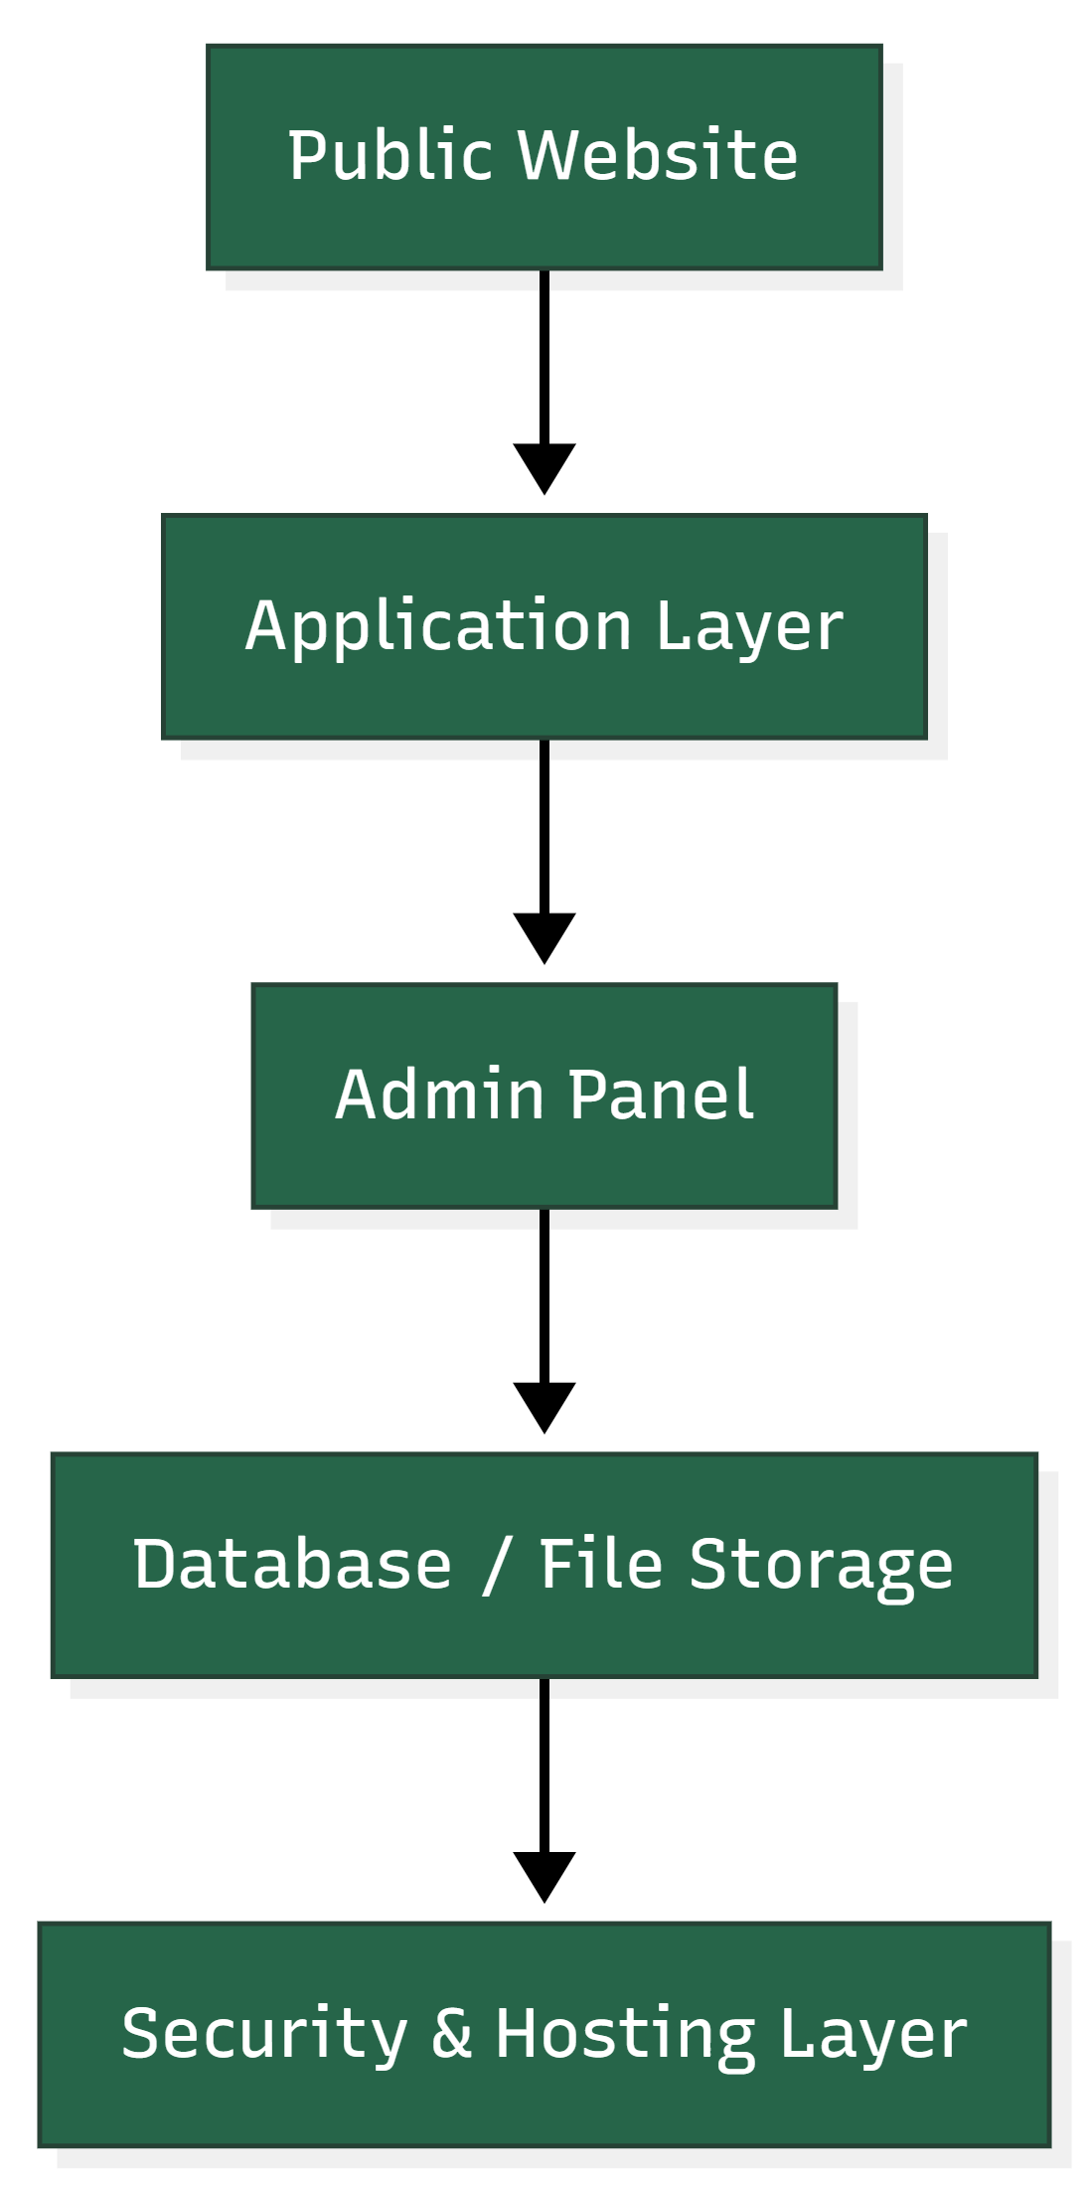

Figure 2. Content Publishing and Approval Flow
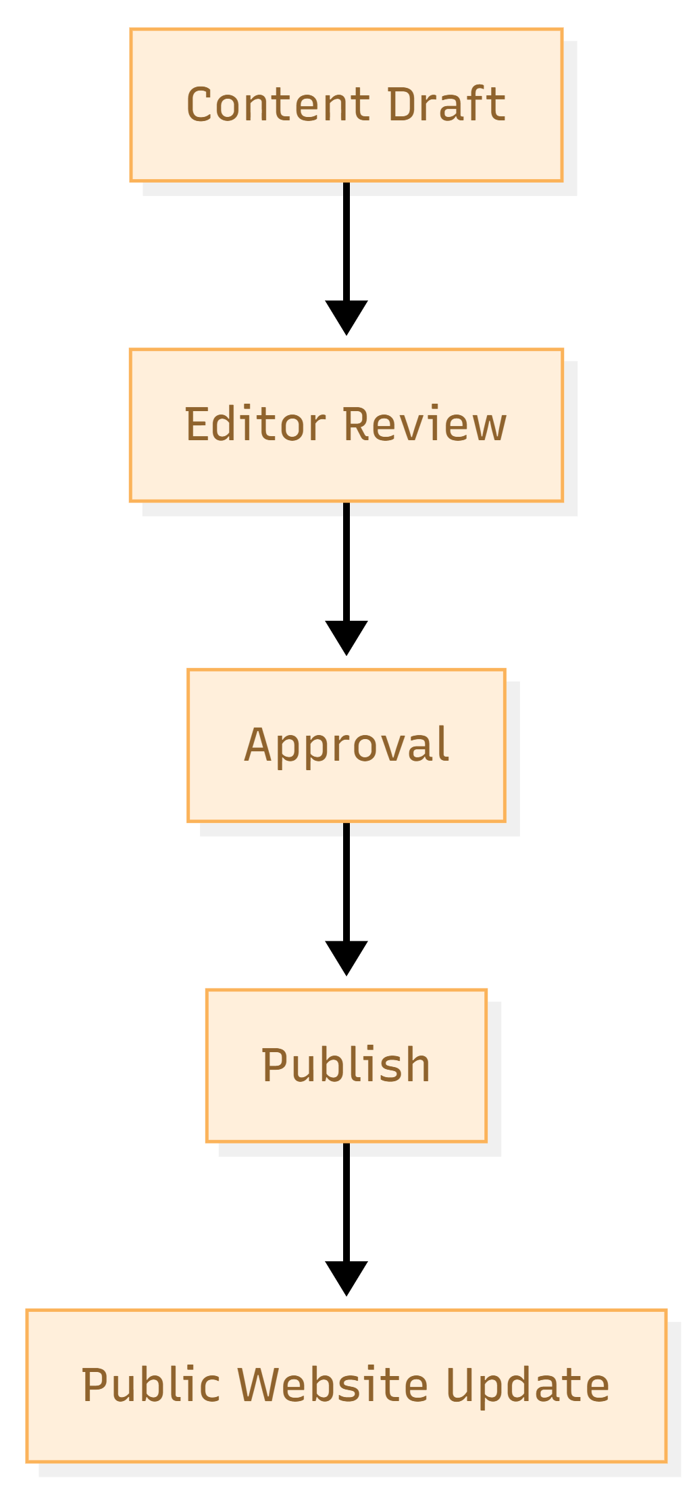

10. Testing and Quality Assurance
Testing will be conducted as an essential stream throughout the project, with specific emphasis on both website quality and post-incident assurance.
9.1 QA coverage
- Functional testing for all approved public website modules and content workflows.
- Cross-browser and responsive testing for major desktop, tablet, and mobile breakpoints.
- Regression testing to ensure retained pages and retained admin functionality remain stable.
- Content management validation including role-based actions and approval steps.
- Form validation testing for contact, enquiry, and subscription-related flows where applicable.
- Search validation to verify expected indexing, filtering, and content discovery behavior.
9.2 Security assurance coverage
- Access control verification, password policy and MFA checks where configured.
- Environment review for staging/production separation, secure configuration, and restricted access paths.
- Dependency and source validation before production release.
- Vulnerability scanning and remediation verification.
- Backup and recovery validation for operational resilience.
- Go-live monitoring and post-release stabilization checks.


11. Proposed Implementation Timeline
Total implementation timeline: 3.5 months

12. Deliverables
- Requirements validation summary and final sitemap/content structure.
- Approved UI/UX design package for key responsive website screens and reusable components.
- Fully developed public website aligned to the approved scope.
- Complete admin panel with role-based management and content workflows.
- Configured staging and production-ready deployment setup.
- Search-ready content structure with tagging/filtering foundation.
- QA issue closure support.
- Deployment and go-live support.
- Basic admin training and handover documentation.
- Source code, deployment package, and production handover materials.

13. Assumptions and Scope Boundaries
- The proposal is based strictly on the supplied requirement and security-recovery documents.
- Financial proposal, hosting subscription fees, and third-party license fees are excluded from this document.
- Content writing, bulk content entry, and translation are assumed to be provided or reviewed by the client unless separately agreed.
- External platforms referenced in the requirement will be linked or integrated only to the extent explicitly required and technically feasible.
- Advanced AI search behavior, if desired beyond structured search and metadata readiness, should be considered as a controlled subsequent enhancement.
- SEO recovery after prior compromise depends partly on search-engine re-evaluation cycles, even after technical remediation.

14. Conclusion
BRAC JPGSPH requires more than a standard institutional website refresh. The requirement set calls for a modern, professionally branded and easily manageable platform, while the security recovery context requires disciplined rebuilding, environment hardening, and careful release governance. A from-scratch redevelopment with new UI/UX, a complete admin panel, and security-led deployment is therefore the most appropriate implementation path.
The proposed approach remains intentionally practical: it covers the required website and administrative capabilities, supports future extensibility, and incorporates the core security and quality controls necessary for a stable, credible, and maintainable digital platform.

